Group 101

COMP303 Project

Defect Tracker Web app

Team members & responsibilities

* Farhana Sharmin : Database design , DAO & Business Logic
* Anand Kasote: UI Design & CSS
* Michael Dator: CSS & Entity modfels
* Devdas Chatterjee: Configuration, Controller & Services

This app uses the following technologies and framework

1. Spring 5

2. Spring security 5

3. Hibernate 5

4. Maven as build tool for dependency management

5. MySql database

6. Server: Wildfly 11.0, Tomcat 8.5/9.0

Compatibility: Java 1.8

Dynamic web Module 3.1

The app uses role based authentication. There are 4 users in the app

Users role

===== =====

md admin

fs cma

ak cma

dc cma

Default password is test123

There are 5 Functionalities in the app which have been implemented

1. User Authentication--This uses JDBC authentication with bcrypt encryption.

2. Application--This lists all the Applications with CRUD functionalities

3. Vendors--This lists all the vendors who supplied those Applications with CRUD functionalities

4. Defect Fix List--This is the list of all the defects in all the Applications with their deployment status with CRUD functionalities

5. Search functionalities in defect list. A user can search by key word, Application name or Vendor name.

Installation instructions:

1. Make sure you have MySQL server installed
2. Execute the database scripts (2 scripts) in mySQL
3. Install STS and Maven plugin in Eclipse
4. Import the project into Eclipse as war file or Zip file
5. Update the project by Updating maven
6. Change MySQL database access credentials in both the properties file

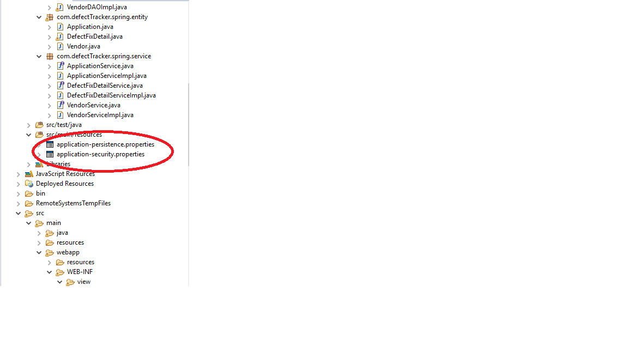

Run the application on server